 | HONG KONG JOINT COUNCIL FOR PEOPLE WITH DISABILITIES
IN PARTNERSHIP WITH THE HONG KONG COUNCIL OF SOCIAL SERVICE
NATIONAL MEMBER ORGANIZATION OF REHABILITATION INTERNATIONAL
 | 香 港 復 康 聯 會
 | 香港社會服務聯會合作伙伴．國際復康總會成員機構
REVISED

M E M O R A N D U M

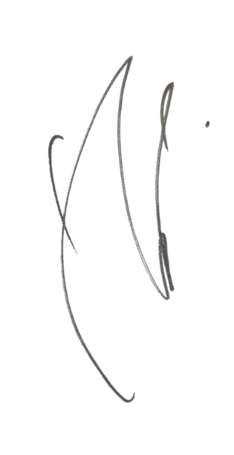
TO : All Members of Hong Kong Joint Council for People with Disabilities
Concerned Government Departments and Organizations

FROM : Eddie SUEN
Secretary General

SUBJECT : Rehabilitation Overseas Exposures 2012

DATE : 24 July 2012

Further to the memo dated 11 July 2012, Hong Kong Joint Council for People with Disabilities has solicited funding to subsidize rehabilitation NGOs / self-help groups on 50% basis for attending overseas events. Please note that the event date of APDF Conference, estimated expenses per delegate and subsidized places are amended. The detail is as follows:

 | Event | Subsidized places
1 | 2012 APDF Conference for Real Rights  [26 - 30 October (5 days); Incheon, KOREA]  Please note that the deadline for early-bird registration is on or before 30 July 2012. To enjoy the early-bird rate, please submit the registration form to the Congress Secretariat before the deadline. | 24  (including 2 staff of the Joint Council)
2 | The 8th World Blind Union General Assembly  [12 - 16 November (5 days); Bangkok, THAILAND] | 5

2. For information of the Event, including the estimated expenses per delegate and selection criteria on subsidy, please visit the below HKCSS website:-

http://www.hkcss.org.hk/rh/overseasevents/index2012.html

. . . /2

- - 3 -

3. To apply for subsidy, please complete the Subsidy Application Form(s) which can be downloaded at the above website. Those who wish to join the Joint Council’s delegation as a self-financed member, please complete the Application Form for Self-financed Applicant, which can be downloaded at the website as well. If you have difficulties with internet access, please contact us to make alternate arrangement. Completed forms should reach Hong Kong Joint Council for People with Disabilities, Room 1212, Duke of Windsor Social Service Building, 15 Hennessy Road, Wanchai, Hong Kong before 17 August 2012 (Friday). Please mark “Confidential” on the envelope and all information will be treated in strict confidence. Please note that late applications will not be considered.

4. Should there be any questions on the subsidy application procedures, please contact Ms. Agatha TANG, Rehabilitation Officer, at 2864 2939 or by email to agatha.tang@hkcss.org.hk.

5. Thank you for your attention.

